Samuel Ginn College of Engineering & College of Agriculture
Biosystems Engineering
BSEN 3310 – Hydraulic Transport

Naomi Pitts
Lab Group 5
Rheology Lab

Abstract
In this lab, a Bohlin rheometer was used to analyze the fluid properties of various subjects. The Peltier system was used to ensure the precision and stability of each sample temperature while measurements were taken. A concentric system measuring system was used to determine the rheological properties. The measurement process was repeated for each of the following fluids: two types of dish soap, starch-water, mayonnaise, and canola oil at various increasing temperatures). Using Excel, the collected data was interpreted through graphs that show the relationship between the shear rate and shear stress and allowed fluid properties of different fluids to be compared. Equations provided by trendlines on each graph provided further theoretical information on viscosity, flow behavior index, and consistency coefficient. It was determined whether certain fluids are considered Newtonian, pseudoplastic, or dilatant. Each of these fluid properties including viscosity, flow behavior index, and consistency coefficient can be applied to the design of flow processes.

Introduction
Students are to become familiar with the function of the Bohlin rheometer during this lab to collect data. The rheometer is a device with the ability to measure how fluids react to applied forces. Stress is exerted on the fluid being tested by the device and the results are measure by the software within the machine.
Viscosity is an expression of a fluid’s resistance to flow caused by internal friction, it is measured in the units of force per unit area. The focus of this lab is on the fluid properties of liquids rather than gases, which have notable different relationships to viscosity. Typically, viscosity increase as intermolecular forces within a liquid fluid increase (Cengal 2011). The Temperature of a fluid has a strong influence on viscosity (eq. 1)
$μ=a{10}^{\frac{b}{(T-c)}}$ (1)

Where T is the absolute Temperature and a, b, and c are experimentally determined constants. Temperature has such an effect on viscosity because liquids hold more energy at higher temperatures and therefore have stronger intermolecular forces (Cengal 2011). In this lab, the viscosity of multiple liquid fluids will be determined from flow behavior data. Determining the viscosity of a fluid will allow for further understanding of how the different fluids behave.
Flow behavior index and Consistency coefficient are additional fluid properties that were analyzed during this lab through experimental means. The consistency coefficient, denoted as K, measures the average viscosity of a non-Newtonian fluid. The behavior index, denoted as n, measures the deviation of fluid from non-Newtonian flow (Pang 2020). Fluids can behave as Newtonian, pseudoplastic, or Dilatant depending on this value. The consistency and flow behavior index characterizes the shear thinning of a fluid. Shear-thinning is a character of non-Newtonian fluids, it means that the fluid viscosity will decrease under increased stress (Hall 2012). Dilatant fluids viscosity increases as the shear rate increases and Pseudoplastic’s viscosity decreases as the shear rate increases. Dilatant fluids and pseudoplastic are both non-Newtonian. The viscosity of Newtonian fluids does not fluctuate on the shear rate and is held constant at a given temperature.

Objectives

The purpose of this lab is to determine the flow behavior of multiple fluid products using a Bohlin rheometer (Model CVO-100; Bohlin Instruments, Gloucestershire, United Kingdom). Students will be introduced to the rheometer and develop an understanding of how it functions to determine the Shear stress and Shear rate. From this data, students will derive basic equations using Excel that will reveal additional theoretical properties. The relationships between the viscosity of different fluids will be made apparent through this graphical analysis. Students will gain a better understanding of the effects each rheological parameter has on a fluid.

Materials and methods

Rheological tests were carried on the following samples: Ajax dishwashing soap, Dawn dishwashing soap, starch-water, mayonnaise, and Canola oil at different temperatures. A Bohlin rheometer (Model CVO-100; Bohlin Instruments, Gloucestershire, United Kingdom) was used to collect the shear stress-shear rate data for each sample at the desired temperature. The Peltier system of the rheometer was used to ensure precise and stable control of sample temperature during the shear stress-shear rate measurements. Both the rheometer and the Peltier system were controlled using software provided by the manufacturer of the rheometer. A concentric cylinder measuring system was used to evaluate the rheological properties of the sample. This measuring system consisted of a 25-mm diameter rotating bob (inner cylinder) located in a 27.5-mm diameter fixed cup (outer cylinder). The bob was used to shear about 13 mL of the liquid sample contained in the annular gap between the cup and bob. Shear rates were ramped from the lowest shear rate to the highest shear rate after a sample reach the desired temperature (10ºC, 25 ºC, 40 ºC, 55 ºC, 70 ºC, 85 ºC). Data collected by the rheometer software were processed by Excel spreadsheet.

Results and discussion

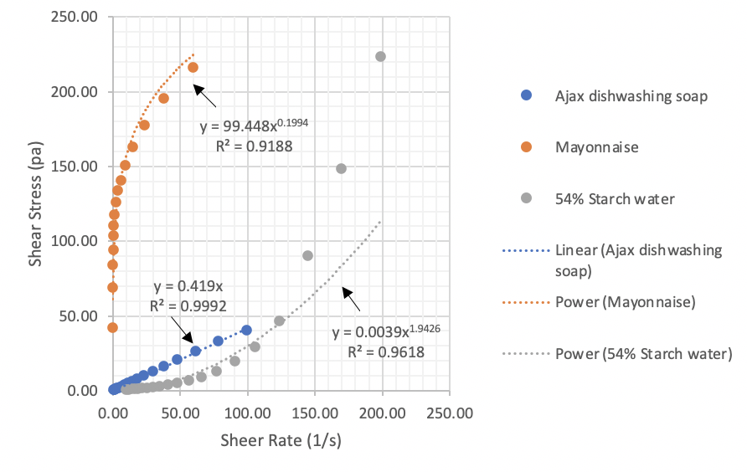
Figure 1. Shear Stress versus Shear Rate for Ajax, Mayonnaise, and Starch Water

Using Excel, power trendlines were generated for each fluid using the Shear stress and Shear rate. From these equations rheological data, consistency coefficient, and flow behavior index, can be estimated. The equation for these power trendlines is $y=kx^{n}$, Where k is the consistency coefficient and n is the flow behavior index (dimensionless) for the non-Newtonian fluids (Hall 2012). The slope (k value) of the trendline is the viscosity. Beneath each equation (Figure 1) is the R² Value for the trendline, this is a statistical measure that represents how the variance for one variable is contributed to another. The R², or coefficient of determinations, essentially measures the strength of the relationship between two variables. The Ajax, Mayonnaise, and Starch water had R² Values of 0.9992, 0.9188, and 0.9618 respectively.
Whether a fluid is Newtonian, pseudoplastic, or dilatant can be determined by the flow behavior index.
Newtonian fluids have a flow behavior index equal to 1. The viscosity of Newtonian fluids remains constant at a given temperature, regardless of how shear rate changes. Dilatant fluids have a flow behavior index greater than 1 while pseudoplastic has an index of less than 1. The n value, flow behavior index, of the equations shows that the Ajax dishwashing soap is Newtonian with a value of 1. The Mayonnaise behaves as a pseudoplastic with an n value of 0.1994 and the Starch Water mixture is a Dilatant the n value being 1.9426. The viscosities of the Mayonnaise and starch water fluctuate on the shear rate.

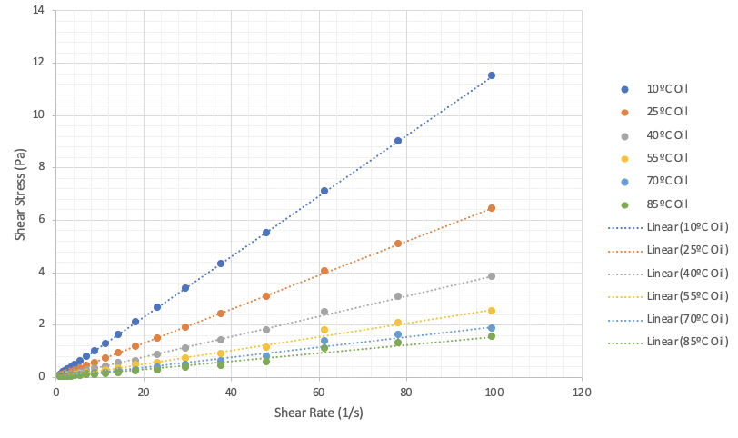

Figure 2. Shear Stress versus Shear Rate of Canola Oil at Different Temperatures

Canola Oil Temperature | Trendline Equation | R² Value
10 ºC | y = 0.1155x | 1
25 ºC | y = 0.065x | 0.9999
40 ºC | y = 0.0387x | 0.9992
55 ºC | y = 0.026x | 0.9953
70 ºC | y = 0.0194x | 0.9892
85 ºC | y – 0.0155x | 0.9834
Table 1. Trendline equations and R² Values for Canola Oil at Different Temperatures

The shear stress and shear rate of Canola oil at several different controlled temperatures were plotted in Excel (Fig 2). Starting with a temperature of 85 ºC, the slope of each line becomes steeper as the temperature of the oil is decreased in increments of 15 ºC for each trial. Using Excel to determine trendline equations for the data at each temperature, the viscosity can be determined (Table 1). The coefficient, or k value, in each linear equation reveals the viscosity of the fluid at each temperature. This data was platted on a separate graph with viscosity as a function of temperature (Fig 3). The viscosity of the Canola Oil decreases exponentially as the temperature rises. The trend lines are linear with n values equal to 1, so the Oil behaves as a Newtonian fluid at each temperature and its viscosity behaves independently of shear rate (Pang 2020).

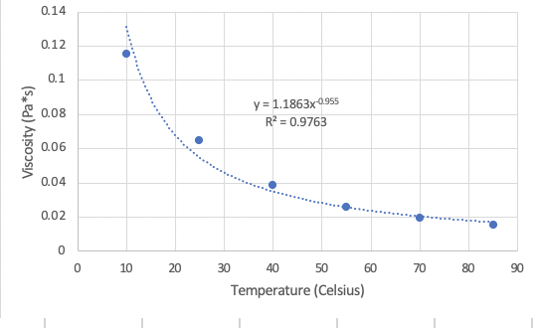

Figure 3. Viscosity of Canola Oil as a Function of Temperature

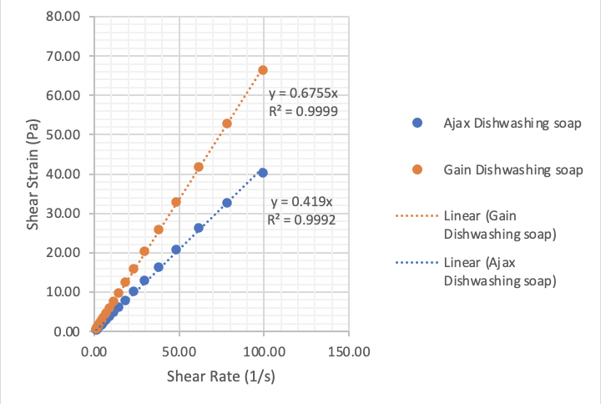
Figure 4. Shear Rate versus Shear Stress for Ajax and Gain

The shear rate and shear stress of two types of dish soaps were plotted against each other on a graph for comparison. Both soaps behave as Newtonian fluids with n values equal to 1. The Gain had a much steeper slope, therefore k value and theoretical viscosity, than that of the Ajax (Fig 4).

Conclusions

Ajax, Gain, and Canola oil at Each varying temperature behaved as Newtonian Fluids. Each is observed to have flow behavior index equal to 1, apparent by their linear trendlines. When it came to the olive oil, the fluid remained Newtonian at each temperature, though the viscosity did increase as the temperature decreased.
The Mayonnaise and Starch water are both determined to be non-Newtonian fluids, behaving as a pseudoplastic and dilatant respectively. The rheological data gather by this lab can be applied to the design of flow processes for each fluid (Shountian 2020). It is important to consider the viscosity of soap when designing the dispenser that it could potentially flow through. If the viscosity is too high the soap will not dispense and if it is too low, it will leak out when not needed. Though typically, Soaps of higher viscosity tend to be more effective (Sherman 1903). A more viscous soap means that it will better adhere to dirt and grime for cleaning. It will be more resistant to seeping off of surfaces when coming into contact with water, which often happens during washing.
Ajax and Gain were both soaps, but Ajax had a higher viscosity of the two. This is likely due to the two soaps, for separate purposes, having different formulas. The Gain being more diluted by some addition to the mixture could lead to is being less viscous than Ajax. Gain is meant for washing machines that utilize mechanical energy through spinning to clean clothes. The mechanism used by washing machines allows for the soap to be less viscous so it can disperse and suds throughout the entire load during washing. Ajax is designed for hand washing dishes, so there is less mechanical energy to do the scrubbing. It’s more beneficial for the soap used for handwashing to have a higher viscosity so that it remains present to be scrubbed for longer.
Similar to soap, the viscosity of condiments such as mayonnaise should be considered when designing any device to dispense that particular fluid. Viscosity measurements are often utilized in the food industry to improve cost effectiveness and the efficiency of production.
It was noted that the starch water and Mayonnaise behave on opposite ends of the spectrum with one being a pseudoplastic and the other being dilatant. Starch water is known to become more solid when put under stress but behave as a liquid otherwise. This behavior is characteristic of pseudoplastic and has to do with the miniscule size of the starch particles and how they respond to stress. Meanwhile with a condiment such as Mayonnaise flow at a higher rate when pressure is applied due to the viscosity increasing.

References

Cengal, Yunus A, Robert H Turner, and John M Cimbala. Fundamentals of Thermal Fluid Science. 4th ed. New York, New York: McGraw-Hill Education, 2011.
Hall, Stephen. Rules of Thumb for Chemical Engineers. Elsevier Inc, 2012.
Li, Shoutian, Mark T. Devlin, Gregory P. Liesen, C. Tom West, and Tze-Chi Jao. "Low Temperature Rheology of Engine Lubricants: Investigation of High Used Oil Pumping Viscosity." SAE Transactions 109 (2000): 2895-905. Accessed September 16, 2020. http://www.jstor.org/stable/44746079.

Pang B., Wang S., Chen W., Hassan M., Lu H. Effects of flow behavior index and consistency coefficient on hydrodynamics of power-law fluids and particles in fluidized beds
(2020) Powder Technology, 366 , pp. 249-260.
Sherman, H C, and Herbert Abraham. “The Viscosity of Soap in Oil Analysis.” ACS Publications. American Chemical society, May 28, 1903. https://pubs.acs.org/doi/pdfplus/10.1021/ja02011a013?src=recsys.
T. Lonstrup, P. Bennett, M. McMillan, and W. Waddey, eds., The Relationship Between Engine Oil Viscosity and Engine Performance. (West Conshohocken, PA: ASTM International, 1977), https://doi.org/10.1520/STP621-EB

